Lab 3.6 - Complex SELECT statements

## Instructions

1. Answer the below question in the boxes.
2. Please submit the assignment after you finish.

## Open the Movies database

Follow the step illustrated in the lecture note to open the Movies database using DB Browser for SQLite. You should see 5 tables in the database.

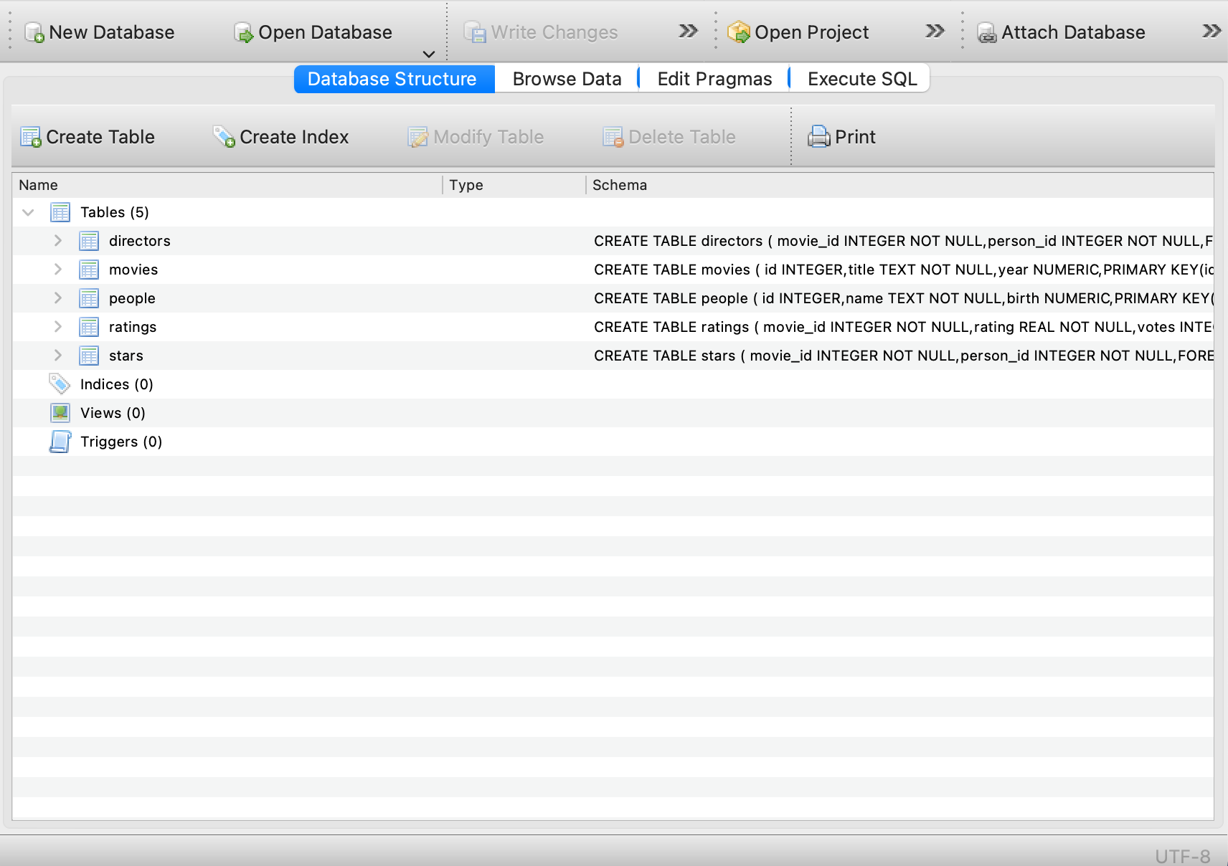

## 

## Understanding the database

1. Study the table schema and the data in the “people” and “directors” table and describe the relation between the tables “people” and “directors”

|  |
| --- |

1. Study the table schema and the data in the “movies” and “directors” table and describe the relation between the tables “movies” and “directors”

|  |
| --- |

## Query Exercises

1. Write a SQL query to obtain the movie_id who is directed by “Joris Ivens” without using WITH keyword

**Expected Output:** a table with a single column for the movie_id of the director’s movie.

|  |
| --- |

1. Write a SQL query to obtain the movie title who is directed by “Joris Ivens”  
   **Expected Output:** a table with a single column for the movie title of the director’s movie.

|  |
| --- |

1. Organize and rewrite the SQL query of Q1 using WITH keyword  
   **Expected Output:** The SQL query in WITH keyword

|  |
| --- |

1. Write a SQL query to show each person’s name and whether the person is born before 1970, born in 1970, born after 1970  
   **Expected Output:** The SQL query fulfilling the required data

|  |
| --- |

1. Write a SQL query to count the number of people in the “people” table by each birth year.  
   **Expected Output:** The SQL query fulfilling the required data. Note that having the NULL birth year on the query result is normal.

|  |
| --- |

1. Write a SQL query to count the number of directors by each birth year. Only the years with more than 500 directors born are interested.  
   **Expected Output:** a table with two columns for the birth year and count of directors.

|  |
| --- |

**- End of Assignment -**